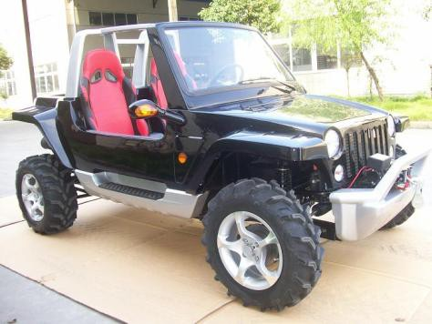
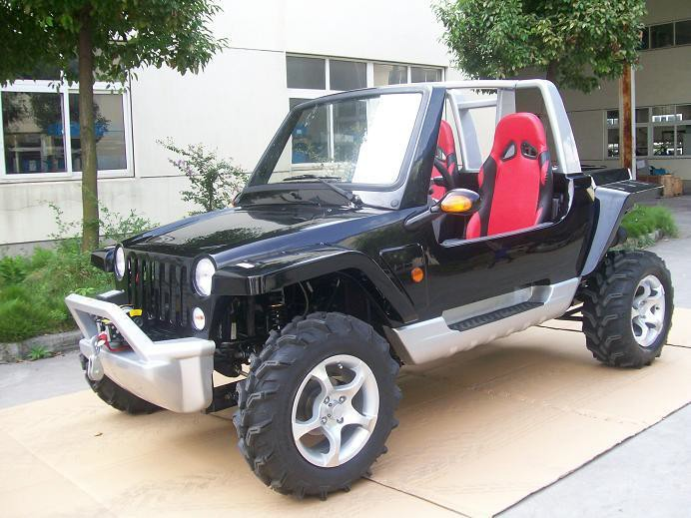

Model Type: ADISGJK800 | Lubrication: SAE 15W-40/SF
Available Color: see below | Transmission: 4-MT with reverse
Size: 3130*1565*1510mm | Maximum load: Double seats/250kg
Wheelbase: 2180mm | Fuel tank: 24L
Front track: 1360mm | Climbing: 25°- 30°
Rear track: 1360mm | Top speed: 85km/h (or limited as customers require)
Ground clearance: 240mm
Engine type: water-cooled, 4-stroke | Front/Rear brake: Hydraulic disc, right foot control
Engine capacity: 800cc | Front/Rear tire: AT27X8-14 / AT27X11-14
Bore x Stroke: 72mm x 66.5mm | Final drive: Shaft drive
Corrected compression ratio: 9.5:1 | Carton size: 2950mm x 2115mm x 895mm
Max output power: 14.9kw/6000rpm | Net weight: 550kg Gross weight: 640kg
Max torque: 70Nm/3500-4000rpm | Quantity: 11pcs/40HQ; 4pcs/20GP
Starting: Electric ＜10s | Optional parts: see the detailed optional equipment in P2
Ignition: Electric Multipoint Injection
FOB SHANGHAI：US$9,000./PC 2WD US$10,560/PC 4WD

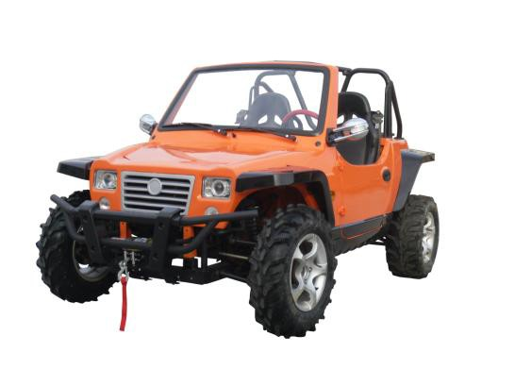
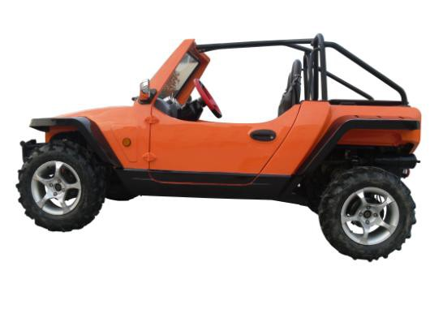
Model Type: ADISGUTV800 | Lubrication: SAE 15W-40/SF
Available Color: see below | Transmission: 4-MT with reverse
Size: 3130*1565*1510mm | Maximum load: Double seats/250kg
Wheelbase: 2180mm | Fuel tank: 24L
Front track: 1360mm | Climbing: 25°- 30°
Rear track: 1360mm | Top speed: 85km/h (or limited as customers require)
Ground clearance: 240mm
Engine type: water-cooled, 4-stroke | Front/Rear brake: Hydraulic disc, right foot control
Engine capacity: 800cc | Front/Rear tire: AT27X8-14 / AT27X11-14
Bore x Stroke: 72mm x 66.5mm | Final drive: Shaft drive
Corrected compression ratio: 9.5:1 | Carton size: 2950mm x 2115mm x 895mm
Max output power: 14.9kw/6000rpm | Net weight: 550kg Gross weight: 640kg
Max torque: 70Nm/3500-4000rpm | Quantity: 11pcs/40HQ; 4pcs/20GP
Starting: Electric ＜10s | Optional parts: see the detailed optional equipment in P2
Ignition: Electric Multipoint Injection
FOB SHANGHAI：US$9,640./PC 2WD US$10,840/PC 4WD
THE ENGINE AND SPEED GEAR BOX ARE CHERY BRAND, NOT MOTORCYCLE ENGINE

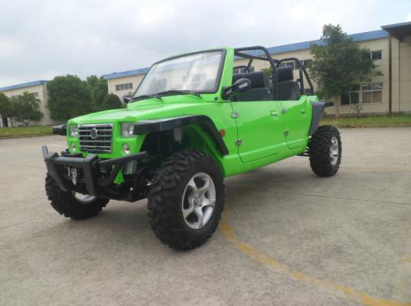 | 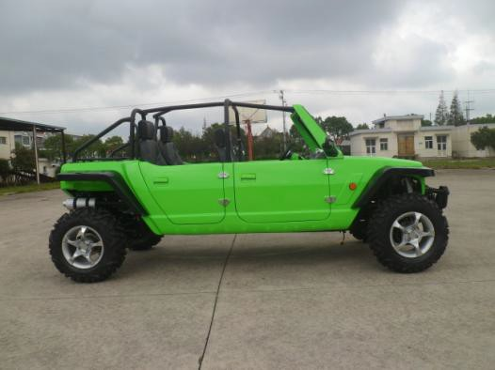
Model Type: ADISGUTV1100 | Lubrication: Force/Splash
Available Color: see below | Transmission: Manual
Size: 3750*1650*1570mm | Maximum load: four seats/400kg
Wheelbase: 2860mm | Fuel tank: 23L
Front track: 1310mm | Climbing: 25°- 30°
Rear track: 1370mm | Top speed: 100km/h (or limited as customers require)
Ground clearance: 260mm
Engine type: Vertical, 4-cylinder, liquid cooled, 4- stroke, DOHC | Front/Rear brake: Hydraulic disc, right foot control
Engine capacity: 1083cc | Front/Rear tire: AT27X9-14 / AT27X11-14
Bore x Stroke: 70mm x 66.5mm | Final drive: Shaft drive
Corrected compression ratio: 9.5:1 | Carton size: 3530mm x 2115mm x 895mm
Max output power: 50kw/6000rpm | Net weight: 840kg (4x4wd) Gross weight: 1050kg (4x4wd)
Max torque: 90Nm/3500-4000rpm | Quantity: 8pcs/40HQ; 6pcs/40GP; 2pcs/20GP
Starting: Electric ＜10s | Optional parts: see the detailed optional equipment in P2
Ignition: Electric Multipoint Injection
FOB SHANGHAI：US$12,500./PC 4WD
THE ENGINE AND SPEED GEAR BOX ARE CHERY BRAND, NOT MOTORCYCLE ENGINE

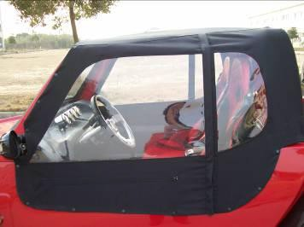  TOP ROOF $100 | 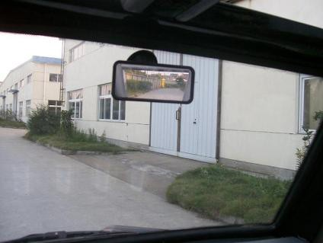  INNER REAR VIEW MIRROR $15
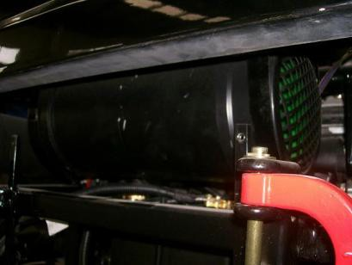  WOOFER $50 | 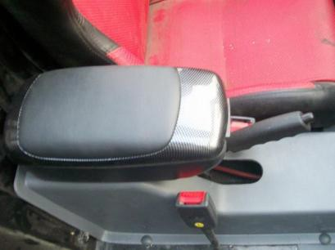  STORAGE BOX AND ARMREST only for 2WD $20
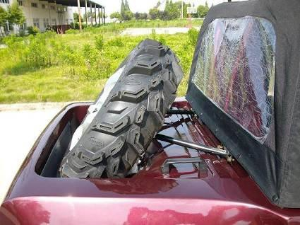  SPARE TIRE $190 | 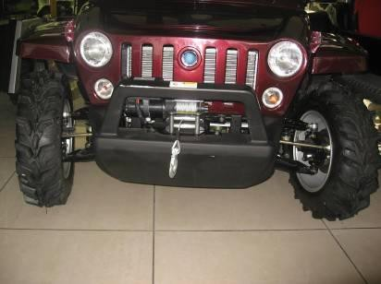  ELECTRIC WICH $100
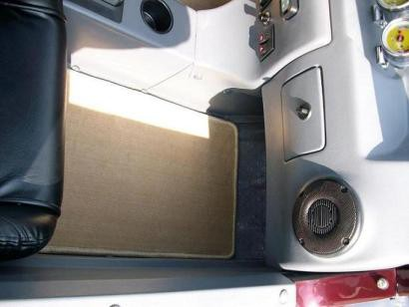  INNER FLOOR CUSHION $40 | 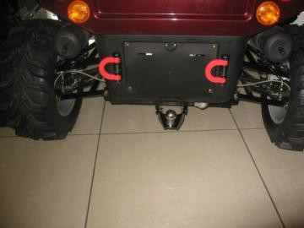  TOW BALL $40

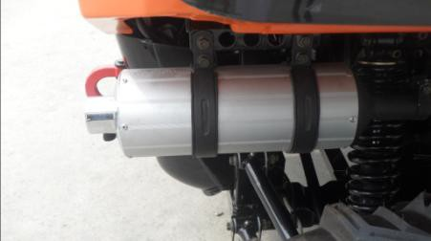  Aluminum muffler+USD72 | 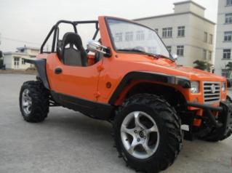  Chroming rear view mirror +USD20
EXCEPT BLACK, WHITE, $180 WILL BE ADDED FOR THE FELLOWING COLORS:  CHINESE RED DARK RED ORANGE BLUE YELLOW | 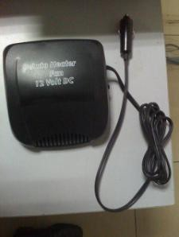12 Volt heater fan $25

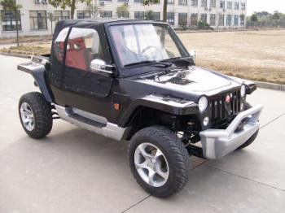
BLACK (BASIC COLOR)

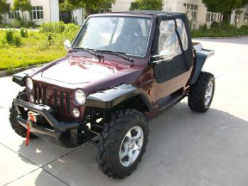 DARK RED 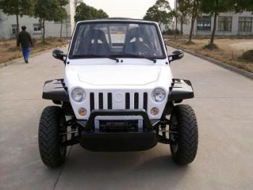 WHITE 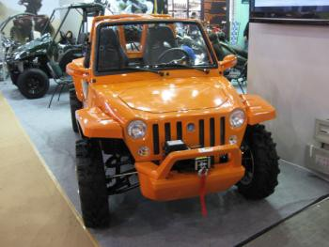ORANGE

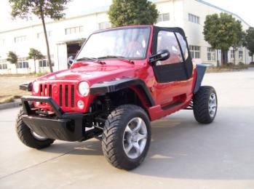
RED

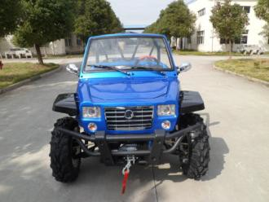
BLUE
Front & Rear Fenders can be painted to be black without extra cost!!

